**Title: Protected area planning to conserve biodiversity in an uncertain world**

**Authors:** Richard Schuster 1,2*, Rachel Buxton1, Jeffrey O. Hanson1, Allison D. Binley1, Jeremy Pittman3, Vivitskaia Tulloch4, Frank A. La Sorte5, Patrick R. Roehrdanz6, Peter H. Verburg7, Amanda D. Rodewald5,8, Scott Wilson1,9, Hugh P. Possingham10, Joseph R. Bennett1

**Affiliations:**

1 Department of Biology, 1125 Colonel By Drive, Carleton University, Ottawa ON, K1S 5B6 Canada.

2 Nature Conservancy of Canada, 245 Eglinton Ave East, Suite 410, Toronto, Ontario, M4P 3J1, Canada.

3 School of Planning, University of Waterloo, 200 University Ave W, Waterloo, ON, N2T 3G1, Canada

4 Conservation Decisions Lab, Department of Forest and Conservation Sciences, 2424 Main Mall, Vancouver, BC V6T 1Z4, Canada.

5 Cornell Lab of Ornithology, Cornell University, Ithaca, NY 14850, USA

6 Conservation International, 2100 Crystal Drive #600, Arlington, VA 22202, USA

7 Institute for Environmental Studies, VU University Amsterdam, Amsterdam, The Netherlands

8 Department of Natural Resources and the Environment, Cornell University, Ithaca, NY 14853, USA.

9 Wildlife Research Division, Environment and Climate Change Canada, 1125 Colonel By Drive, Ottawa, Ontario, Canada, K1S 5B6

10 Centre for Biodiversity and Conservation Science, University of Queensland, St Lucia, Queensland 4067, Australia

*Corresponding author. Email: [richard.schuster@glel.carleton.ca](mailto:richard.schuster@glel.carleton.ca)

Running title: Protected area planning in an uncertain world

Keywords: biodiversity, protected areas, optimization, risk, governance, land use, climate change, optimization

Number of words (Abstract):

Number of words (Manuscript):

Number of figures: 4

Number of tables: 0

Number of references:

**Abstract:** Many of the world’s protected areas face serious threats from – and can be rendered ineffective by – weak governance, land use intensification, and climate change. We evaluated how such risks would affect the size and placement of protected areas required to protect the world’s terrestrial vertebrates. Using hierarchical spatial optimization models, we illustrate how expanding the land area of the global protected area system by only 1.6% could meet conservation targets while reducing exposure to risks. Risks from weak governance drove the greatest changes in spatial priorities for protection, whereas those from climate resulted in the largest increases to area. In particular, conserving wide-ranging species required countries with relatively strong governance to protect more land when bordering nations with comparatively weak governance. Our results underscore the need for cross-jurisdictional coordination and demonstrate how risk can be efficiently incorporated into conservation planning.

**Introduction**

Even amongst a diverse and innovative set of conservation tools, protecting land remains one of the best strategies to stem the biodiversity crisis (Watson et al. 2014) and a cornerstone of international agreements to safeguard biodiversity (Convention on Biological Diversity (CBD) 2020)*.* The effectiveness of a global network of protected areas depends upon the identification of areas that will both meet the needs of species and provide the greatest return on conservation investments. Yet most spatial planning efforts base decisions heavily upon the estimated ecological value of land (Venter et al. 2014; CBD 2020) and carry the tacit, but often incorrect, assumption that protection will be enforced, effective, and permanent. Despite evidence that protected areas are subject to risks associated with weak governance (e.g., political instability and corruption; , land use intensification (e.g., deforestation and degazetting of parks; Tesfaw et al. 2018), and climate change (e.g., extreme weather events; Maxwell et al. 2019), few plans have explicitly considered these risks (McBride et al. 2007). Here we demonstrate how the resilience and performance of protected areas may be improved if we expand the planning lens to include risks as well as ecological value.

We considered the following three broad categories of risk, which we defined as factors likely to diminish the long-term effectiveness of protected areas: (i) governance, (ii) land use, and (iii) climate. These elements of risk, and the metrics we chose to represent them, represent only a few options among the many that agencies may use. However, the approach we propose is flexible and can easily incorporate additional or alternative risk metrics (Garcia et al. 2014).

**Methods**

We considered the influence of risk categories on allocating protection decisions at a global scale in suitable habitat for all 29,350 vertebrate species from the IUCN Red List of Threatened Species (IUCN 2019) using a multi-objective optimization approach. To incorporate risk categories, we built on the minimum set problem, where the objective is to reach species distribution protection targets while accounting for one constraint such as land cost or area ( Ball et al. 2009; Moilanen et al. 2009). We expanded this approach to include multiple objectives accounting for risk in the problem formulation, by treating each risk layer as a separate objective in the problem formulation (Deb 2014).

Biodiversity Data

We produced area of habitat (AOH) for 10,774 species of birds, 5,219 mammals, 4,462 reptiles and 6,254 amphibians with available IUCN range polygon data following the procedure outlined in Brooks et al. (2019). Species range polygons obtained from the IUCN Red List spatial data (<https://www.iucnredlist.org/>) and Birdlife International (<http://datazone.birdlife.org/species/requestdis>) were first filtered for ‘extant’ range then rasterized to a global 1 km grid in the Eckert IV equal area projection. Individual species range rasters were then modified to only include land cover classes that match the habitat associations for each species. Habitat associations were obtained from the IUCN Red List species habitat classification scheme and were matched to ESA land cover classes for the year 2018 following Santini et al. (2019). ESA land cover classification data was aggregated from 300 m resolution to match the global 1 km grid using a majority rule. Species ranges were additionally filtered so only areas within a species’ accepted elevational range were included. Global elevation data derived from SRTM was obtained from WorldClim v. 2 (Fick & Hijmans 2017). For bird species, seasonal range codes 1-3 (1=year-round; 2=breeding range; 3=non-breeding range) were processed individually and stored as separate range files where applicable.

Basic administrative delineations

National boundaries were derived from the Global Administrative Areas database (http://gadm.org). We obtained protected area boundaries from the World Database on Protected Areas (https://www.protectedplanet.net). Following standard procedures for cleaning the protected area dataset (Butchart et al. 2015), we (i) projected the data to an equal-area coordinate system (World Behrman), (ii) excluded reserves with unknown or proposed designations, (iii) excluded UNESCO Biosphere Reserves (Coetzer et al. 2014), (iv) buffered sites represented as point localities to their reported area, (v) dissolved boundaries to prevent issues with overlapping areas, and (vi) removed slivers (code available at https://github.com/jeffreyhanson/global-protected-areas). After the protected area data were modified as described above, we overlaid the protected area boundaries with a 10 x 10 km grid covering the Earth. These spatial data procedures were implemented using ArcMap (version 10.3.1) and python (version 2.7.8).

Governance risk

We used worldwide governance indicators from the World Bank (Kaufmann et al. 2011) to capture governance risk. The indicators include six scaled measures: voice and accountability; political stability and absence of violence; government effectiveness; regulatory quality; rule of law; and control of corruption (see Table S4 for definitions). We chose these indicators because evidence suggests that they reliably predict protected area effectiveness (Barnes et al. 2016) and state investment and efforts for biodiversity conservation (Coetzer et al. 2014). For each country, we used a mean of annual averages of all six measures (Baynham-Herd et al. 2018) (Figure S1).

Land use risk

We used a global land systems map produced by Kehoe et al. (2017) to incorporate the risk of land-use change. This map is based on a global land systems map for the year 2000 (Asselen & Verburg 2012) at a 9.25 km2 spatial resolution but is refined based on recent land-cover and land-use datasets to a spatial resolution of 1 km2. Kehoe et al. (2017) further estimated the impact of land use and land use intensity on biodiversity, with data originating from the PREDICTS project (Hudson et al. 2014). They first matched their land-systems classes to varying intensity levels for each land use type (for detailed conversion table, see Asselen & Verburg (2012)). This allowed Kehoe et al. (2017) to calculate average biodiversity loss per land system (relative to an unimpacted baseline) by taking the mean model estimates of biodiversity loss per land use intensity class from previous work (Hudson et al. 2014). The result gives average relative biodiversity gain or loss per land-system class. Here, we used their modelled mean estimates (following Newbold et al. (2015)) of relative percent biodiversity change for each land-system class for species abundance as a measure of the land use pressure (Figure S2).

Climate risk

We used, velocity of climate change, which is an instantaneous measurement of how projected temperature increases translate to horizontal velocity on the landscape (Loarie et al. 2009). It is an integration of both the rate of change in average climate and landscape properties that govern how bands of similar temperature redistribute spatially as climate changes. For example, in a region with high topographic diversity, a species may be able to track its climatic niche through relatively small dispersal distances (e.g. 10s or 100s of meters) upslope or downslope. By contrast, keeping pace with preferred climate under the same magnitude of temperature rise in the plains may require much larger dispersal distances – 100s or 1000s of kilometers. Velocity of future temperature change used here follows the method of Loarie et al. (2009) – and is essentially the ratio of the projected temporal rate of change (C/year) to the spatial rate of change (C/km). Projected temporal rate of change was based on the 20 year mean (2040-2060) projection for mean annual temperature from the HadGEM2-ES model (CMIP5) and the baseline (1960-1990) temperature available from Worldclim v1.4. Spatial rate of change was derived from 30 arc second elevation data and calculated with the ‘terrain’ function from the R ‘raster’ package.

We also explored an alternative measure of climate risk: exposure to extreme events. Detailed methods and results for this alternative measure are provided in the online Supporting Information.

Multi-objective optimization of risk reduction

We createdS

We processed all data described previously to a 10 x 10 km resolution and clipped data to the extent of land based on the global administrative areas database. Our multi-objective approach uses a hierarchical (lexicographic) approach that assigns a priority to each objective, and sequentially optimizes for the objectives in order of decreasing priority. At each step, it finds the best solution for the current objective, but only from among those that would not degrade the solution quality for higher-priority objectives. We considered up to three objectives in our prioritization scenarios, i) governance risk, ii) land use risk, and iii) climate risk. To compare different scenarios, we calculated solutions for each unique objective combination (n = 15), as well as one where we use a constant objective function as the null scenario, as the order of the hierarchy can influence the results. For a detailed mathematical exploration of this method, see the online Supporting Information.

For all scenarios we locked in current protected areas. Following Hanson et al. (2020), we used flexible targets for suitable habitat based on species’ ranges. Species with less than 1,000 km2 of suitable habitat were assigned a 100% target (1,802 amphibians, 893 avian and 645 mammalian species), species with more than 250,000 km2 of suitable habitat were assigned a 10% target (712 amphibians, 4,518 avian and 1,868 mammalian species) and species with an intermediate amount of suitable habitat were assigned a target by log-linearly interpolating values between the previous two thresholds (2,683 amphibians, 5,190 avian and 2,557 mammalian species). Migratory bird species were assigned targets for each seasonal distribution separately. Additionally, to prevent species with very large suitable habitats from requiring excessively large amounts of area to be protected, the targets for species’ distributions larger than 10,000,000 km2 were capped at 1,000,000 km2. This upper limit affected only 206 (1%) species, and sensitivity analyses showed that it had little effect on our results. We acknowledge that these targets are arbitrary; however, they are more precise than previous targets based on species’ ranges (which can contain a large amount of unsuitable habitat), and account for the increased vulnerability of species with smaller range sizes (Pimm & Raven 2000), as well as the difficulty in conserving all habitat for species that occur over large areas.

**Results**

Surprisingly, scenarios that incorporated combinations of the three risk categories increased the priority area by only 1.6% on average (0.08 – 2.52%) compared to the null scenario based solely on ecological value to species. Among single-risk scenarios, accommodating risks due to climate change velocity required the greatest increase in global protected area, compared to scenarios including only governance or land use intensification risks (Table S1).

Scenarios shared many overlapping spatial priorities, which can be considered as reliably good investments in terms of both ecological value and risk management. Most notably, all 15 scenarios prioritized the same 8.5 million km2 (5.8% of global land area) (Fig. 2), much of which was located in Canada, Kenya and Peru (Figure S4). There also was substantial overlap among the priorities across scenarios within Conservation International’s global biodiversity hotspots (Myers et al. 2000), but many high overlap areas lie either outside of (53.3%) or in small areas within hotspots (Figure S5).

At the same time, risk scenarios elicited several prominent shifts in spatial priorities from areas with high to low risk exposure (Fig. 3; Table S2). In some cases, high risks to protected areas in weakly-governed countries could be compensated by expanding protected areas in well-governed neighboring nations (Fig S6). For example, challenges to the transborder conservation of the wide-ranging and IUCN-vulnerable caribou (*Rangifer tarandus*) due to weak governance in Russia (Table S3) were mitigated by increasing the land area protected by Finland from 16.2% to 36.4% (Fig. 4). High exposure to risks from land use change could be offset in a similar fashion, such as by protecting more land in Liberia (32% rather than 22.5% in null scenario) than in the agriculturally-intensifying nation of Sierra Leone (Fig. 4). Likewise, climate-associated risks in Hungary and Serbia (Figure S3) might be tempered by protecting twice as much land (20.4% from 10.2% in null) in nearby Kosovo, which has lower predicted climate velocity (Fig. 4). Addressing risks from extreme weather events (La Sorte et al. 2021) (Figures S7 – S9) also required shifting some priority areas to less climatically volatile locations.

**Discussion**

Although a growing body of literature shows that protected areas are seldom effective if subject to unmitigated risks from land use change, weak governance and climate change (CITE), most spatial planning efforts prioritize land based solely upon estimated ecological value. We show how only small (1.6%) increases in land area may reduce the vulnerability of protected areas to future threats if risk are explicitly considered during planning stages Across all planning scenarios, we identified 8.5 million km2 of priority lands that either uniquely contributed to conservation targets (e.g., high endemism) or were resilient to the risks we modeled. Countries with large proportions of land already in protection (e.g., Brazil with >30%) also had similar priorities for risk vs. null scenarios. Such shared priority areas across planning scenarios are likely to provide good return on conservation investments.

Despite modest differences across scenarios in the global land area required to conserve terrestrial vertebrates, shifts in the locations of priority areas sometimes resulted in substantial increases within any given nation. These asymmetries highlight the importance of cross-jurisdictional coordination (Dallimer & Strange 2015) to promote collaboration and improve the effectiveness protected area systems. In regions where nations vary widely in exposure to risks, coordination may provide opportunity to offset or otherwise mitigate risks by adjusting the geographic locations and/or boundaries of protected areas. Cooperative governance frameworks (Miller et al. 2019) are especially important for countries supporting wide-ranging species that are expected to be impacted by climate, land use, and governance risk across borders (Fig. 3). These governance frameworks, both within and among countries, would need to be developed in an environmentally just and equitable way to deliver benefits to biodiversity and local communities (Martin et al. 2013).

Previous work has incorporated individual risk factors analogous to those we used, including governance (Mascia & Pailler 2011; Eklund & Cabeza-Jaimejuan 2017), climate change (Hoffmann et al. 2019) and land use change (Pouzols et al. 2014; Di Minin et al. 2016) demonstrating the importance of each type of risk in protected area planning. Our results similarly demonstrate that protected area expansion decisions can be profoundly influenced by all three risk factors combined yet show that relatively little additional protected area is required to account for these risks. Our flexible framework and methods can allow conservation agencies to set their own priorities from local to global scales and incorporate different metrics to assess the relevance of different forms and levels of risk.

The conservation community has traditionally neglected to estimate how future changes in climate (Kelly et al. 2020), land use (Di Minin et al. 2016), and socio-economic conditions might compromise the effectiveness of protected areas. Yet, as we work towards an ambitious new plan to curb biodiversity loss (CBD 2020) in a rapidly changing world, we show that incorporating future risk has profound implications for the spatial distribution of protected areas. The risk of weak governance was particularly influential. Surprisingly, incorporating risk into decision-making adds <2% to the total global area required to meet biodiversity targets. Thus, accounting for risk comes at limited extra cost which is likely outweighed by increased likelihood of achieving global biodiversity targets. Our results also emphasize the importance of cross-jurisdictional conservation initiatives, especially in adjacent countries sharing wide-ranging species where risk varies considerably from country to country. Considering risk in conservation decision-making will result in more resilient and effective conservation plans into the future to help safeguard our planet’s biodiversity in the face of the current extinction crisis.

**References**

Asselen, S. van & Verburg, P.H. (2012). A Land System representation for global assessments and land-use modeling. *Global Change Biology*, 18, 3125–3148.

Ball, I.R., Possingham, H.P. & Watts, M.E. (2009). Marxan and Relatives: Software for Spatial Conservation Prioritization. In: *Spatial conservation prioritization. Quantitative methods & computational tools*. Oxford University Press, p. e12625.

Barnes, M.D., Craigie, I.D., Harrison, L.B., Geldmann, J., Collen, B., Whitmee, S., Balmford, A., Burgess, N.D., Brooks, T., Hockings, M. & Woodley, S. (2016). Wildlife population trends in protected areas predicted by national socio-economic metrics and body size. *Nature Communications*, 7, 12747.

Baynham-Herd, Z., Amano, T., Sutherland, W.J. & Donald, P.F. (2018). Governance explains variation in national responses to the biodiversity crisis. *Environmental Conservation*, 45, 407–418.

Brooks, T.M., Pimm, S.L., Akçakaya, H.R., Buchanan, G.M., Butchart, S.H.M., Foden, W., Hilton-Taylor, C., Hoffmann, M., Jenkins, C.N., Joppa, L., Li, B.V., Menon, V., Ocampo-Peñuela, N. & Rondinini, C. (2019). Measuring Terrestrial Area of Habitat (AOH) and Its Utility for the IUCN Red List. *Trends in Ecology & Evolution*, 34, 977–986.

Butchart, S.H.M., Clarke, M., Smith, R.J., Sykes, R.E., Scharlemann, J.P.W., Harfoot, M., … Burgess, N.D. (2015). Shortfalls and Solutions for Meeting National and Global Conservation Area Targets. *Conservation Letters*, 8, 329–337.

CBD (Convention on Biological Diversity). (2020). Zero draft of the post-2020 global biodiversity framework [WWW Document]. URL https://www.cbd.int/doc/c/efb0/1f84/a892b98d2982a829962b6371/wg2020-02-03-en.pdf

Coetzer, K.L., Witkowski, E.T.F. & Erasmus, B.F.N. (2014). Reviewing Biosphere Reserves globally: effective conservation action or bureaucratic label? *Biological Reviews*, 89, 82–104.

Dallimer, M. & Strange, N. (2015). Why socio-political borders and boundaries matter in conservation. *Trends in Ecology & Evolution*, 30, 132–139.

Deb, K. (2014). Multi-objective optimization. In: *Search methodologies*. Springer, pp. 403–449.

Di Minin, E., Slotow, R., Hunter, L.T.B., Montesino Pouzols, F., Toivonen, T., Verburg, P.H., Leader-Williams, N., Petracca, L. & Moilanen, A. (2016). Global priorities for national carnivore conservation under land use change. *Scientific Reports*, 6, 23814.

Eklund, J.F. & Cabeza-Jaimejuan, M.D.M. (2017). Quality of governance and effectiveness of protected areas: crucial concepts for conservation planning. *Annals of the New York Academy of Sciences*.

Fick, S.E. & Hijmans, R.J. (2017). WorldClim 2: new 1-km spatial resolution climate surfaces for global land areas. *International Journal of Climatology*, 37, 4302–4315.

Garcia, R.A., Cabeza, M., Rahbek, C. & Araújo, M.B. (2014). Multiple dimensions of climate change and their implications for biodiversity. *Science*, 344, 1247579.

Geldmann, J., Manica, A., Burgess, N.D., Coad, L. & Balmford, A. (2019). A global-level assessment of the effectiveness of protected areas at resisting anthropogenic pressures. *Proceedings of the National Academy of Sciences*, 116, 23209–23215.

Hammill, E., Tulloch, A.I.T., Possingham, H.P., Strange, N. & Wilson, K.A. (2016). Factoring attitudes towards armed conflict risk into selection of protected areas for conservation. *Nature Communications*, 7, 11042.

Hanson, J.O., Rhodes, J.R., Butchart, S.H.M., Buchanan, G.M., Rondinini, C., Ficetola, G.F. & Fuller, R.A. (2020). Global conservation of species’ niches. *Nature*, 580, 232–234.

Hoffmann, S., Irl, S.D. & Beierkuhnlein, C. (2019b). Predicted climate shifts within terrestrial protected areas worldwide. *Nature communications*, 10, 1–10.

Hudson, L.N., Newbold, T., Contu, S., Hill, S.L.L., Lysenko, I., De Palma, A., … Purvis, A. (2014). The PREDICTS database: a global database of how local terrestrial biodiversity responds to human impacts. *Ecology and Evolution*, 4, 4701–4735.

International), B.I. (BirdLife. (2016). IUCN Red List of Threatened Species: Ara ambiguus [WWW Document]. *IUCN Red List of Threatened Species*. URL https://www.iucnredlist.org/en

IUCN. (2019). The IUCN Red List of Threatened Species. version 1.18.

Kaufmann, D., Kraay, A. & Mastruzzi, M. (2011). The Worldwide Governance Indicators: Methodology and Analytical Issues1. *Hague Journal on the Rule of Law*, 3, 220–246.

Kehoe, L., Romero-Muñoz, A., Polaina, E., Estes, L., Kreft, H. & Kuemmerle, T. (2017). Biodiversity at risk under future cropland expansion and intensification. *Nature Ecology & Evolution*, 1, 1129–1135.

Kelly, L.T., Giljohann, K.M., Duane, A., Aquilué, N., Archibald, S., Batllori, E., … Brotons, L. (2020). Fire and biodiversity in the Anthropocene. *Science*, 370.

La Sorte, F.A., Johnston, A. & Ault, T.R. (2021). Global trends in the frequency and duration of temperature extremes. *Climatic Change*, 166, 1.

Loarie, S.R., Duffy, P.B., Hamilton, H., Asner, G.P., Field, C.B. & Ackerly, D.D. (2009). The velocity of climate change. *Nature*, 462, 1052–1055.

Martin, A., McGuire, S. & Sullivan, S. (2013). Global environmental justice and biodiversity conservation. *The Geographical Journal*, 179, 122–131.

Mascia, M.B. & Pailler, S. (2011). Protected area downgrading, downsizing, and degazettement (PADDD) and its conservation implications. *Conservation Letters*, 4, 9–20.

Maxwell, S.L., Butt, N., Maron, M., McAlpine, C.A., Chapman, S., Ullmann, A., Segan, D.B. & Watson, J.E.M. (2019). Conservation implications of ecological responses to extreme weather and climate events. *Diversity and Distributions*, 25, 613–625.

McBride, M.F., Wilson, K.A., Bode, M. & Possingham, H.P. (2007). Incorporating the effects of socioeconomic uncertainty into priority setting for conservation investment. *Conservation Biology*, 21, 1463–1474.

Miller, R.L., Marsh, H., Benham, C. & Hamann, M. (2019). A framework for improving the cross-jurisdictional governance of a marine migratory species. *Conservation Science and Practice*, 1, e58.

Moilanen, A., Wilson, K. & Possingham, H. (2009). *Spatial conservation prioritization: quantitative methods and computational tools*. Oxford University Press.

Myers, N., Mittermeier, R.A., Mittermeier, C.G., da Fonseca, G.A.B. & Kent, J. (2000). Biodiversity hotspots for conservation priorities. *Nature*, 403, 853–858.

Newbold, T., Hudson, L.N., Hill, S.L.L., Contu, S., Lysenko, I., Senior, R.A., … Purvis, A. (2015). Global effects of land use on local terrestrial biodiversity. *Nature*, 520, 45–50.

Pimm, S.L. & Raven, P. (2000). Extinction by numbers. *Nature*, 403, 843–845.

Pouzols, F.M., Toivonen, T., Di Minin, E., Kukkala, A.S., Kullberg, P., Kuusterä, J., Lehtomäki, J., Tenkanen, H., Verburg, P.H. & Moilanen, A. (2014). Global protected area expansion is compromised by projected land-use and parochialism. *Nature*, 516, 383–386.

Santini, L., Butchart, S.H.M., Rondinini, C., Benítez-López, A., Hilbers, J.P., Schipper, A.M., Cengic, M., Tobias, J.A. & Huijbregts, M.A.J. (2019). Applying habitat and population-density models to land-cover time series to inform IUCN Red List assessments. *Conservation Biology*, 33, 1084–1093.

Schulze, K., Knights, K., Coad, L., Geldmann, J., Leverington, F., Eassom, A., Marr, M., Butchart, S.H., Hockings, M. & Burgess, N.D. (2018). An assessment of threats to terrestrial protected areas. *Conservation Letters*, 11, e12435.

Tesfaw, A.T., Pfaff, A., Kroner, R.E.G., Qin, S., Medeiros, R. & Mascia, M.B. (2018). Land-use and land-cover change shape the sustainability and impacts of protected areas. *Proceedings of the National Academy of Sciences*, 115, 2084–2089.

Venter, O., Fuller, R.A., Segan, D.B., Carwardine, J., Brooks, T., Butchart, S.H.M., Di Marco, M., … Watson, J.E.M. (2014). Targeting Global Protected Area Expansion for Imperiled Biodiversity. *PLOS Biology*, 12, e1001891.

Watson, J.E., Dudley, N., Segan, D.B. & Hockings, M. (2014). The performance and potential of protected areas. *Nature*, 515, 67–73.

**Acknowledgments:** We thank Alison Johnston, Peter Arcese, Steven Cooke and Lenore Fahrig for helpful discussions. RS was funded by the Liber Ero Fellowship Program. JRB was funded by the Natural Science and Engineering Research Council of Canada (NSERC) Discovery Grant 2016-06147 and Environment and Climate Change Canada Grant GCXE19S058.

**Competing interests:** The authors declare no competing interests.

**Data and materials availability:** All data, scripts and full results are available on Open Science Framework (OSF) and will be assigned a DOI once the manuscript is in print: <https://osf.io/e2fuw/?view_only=46eb2e525daf42d29df318a92762d885>

**Figures**



**Figure 1:** Spatial representation of priority areas for protection to account for governance, land use and climate risk. Accounting for these risks to protected area effectiveness to produce more resilient conservation networks would require 23.5% of land surface to reach suitable habitat protection goals (*26*) for vertebrate species from the IUCN Red List of Threatened Species (*20*).

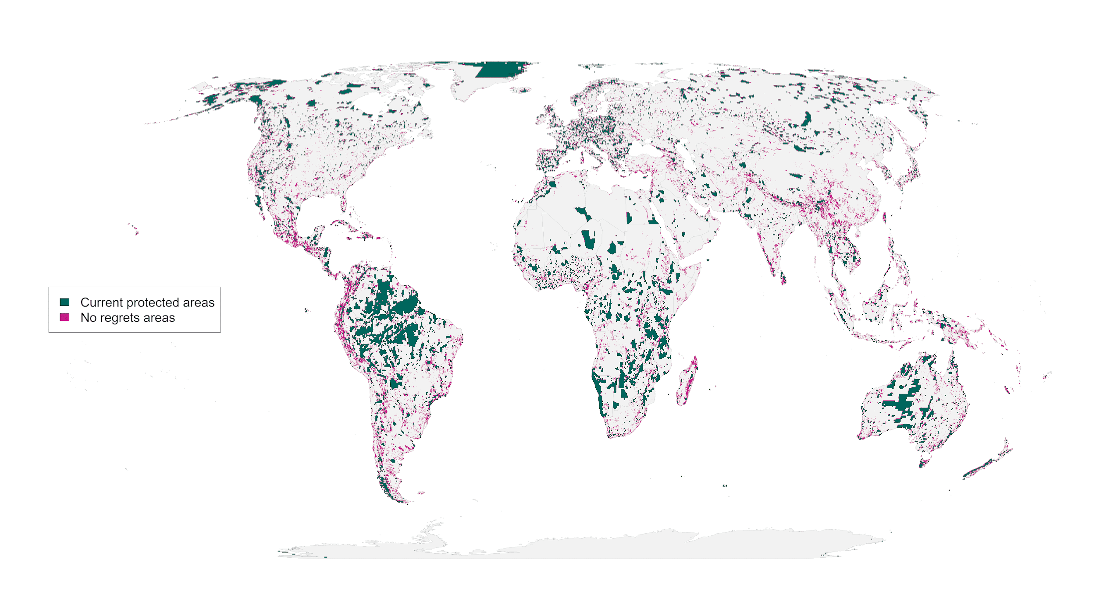 **Figure 2**: “No regrets” areas comprising 8.5 million km2 of land that was identified as priority habitat for protection regardless of the risks included in our analysis.

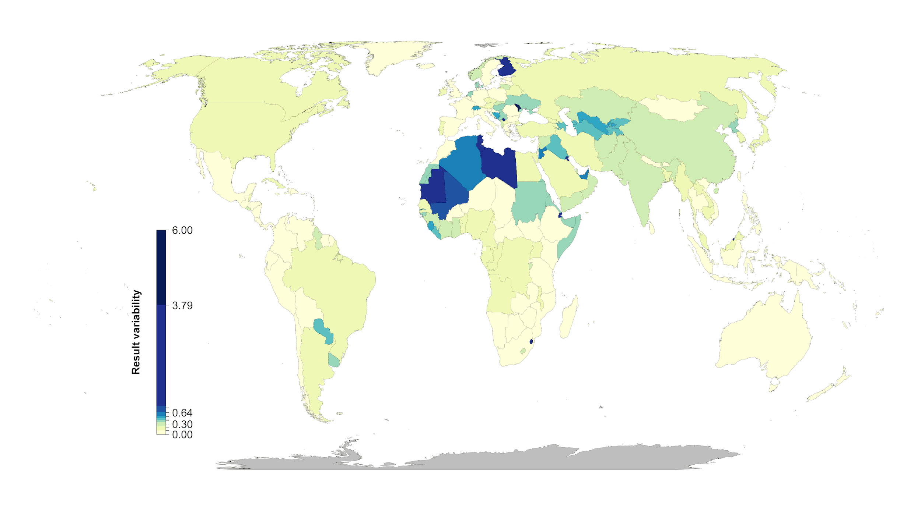

**Figure 3:** Percent country-level variation between the null scenario and the 15 scenarios including risk. Countries whose results are consistent across the 15 scenarios (e.g., Mexico) have low variation, while countries whose results are less consistent across the 15 scenarios (e.g., Finland) have high variation. The kmeans method (*79*) was used to generate class intervals for visualization.

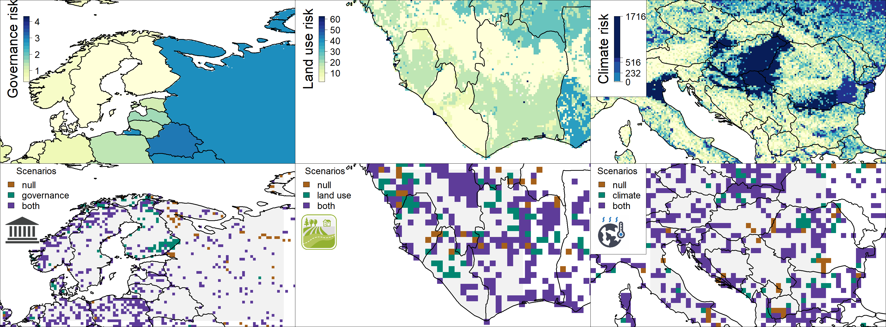

**Figure 4:** Contrast of using individual risk objectives (governance, land use, climate) to the null scenario of uniform objective structure. The top panels represent the individual risk data for the focal regions. In the bottom panels brown shows null, green the specific risk objective scenario results, and purple where both scenarios agree. The figures show how the spatial configuration of the solutions changes when risk is considered in a scenario. Governance focus is on Finland and Russia, land use risk on Sierra Leone and Liberia, and climate risk on Serbia, Hungary and Kosovo.